Reg. Number:
Model Question Paper
Programme |  |  | : | B.TECH (CSE) | Max. Mark | 100
Course Code &  Course Title |  |  | : | BCSE415L  Human Computer Interaction | Duration | 3 Hrs
General Instructions:
- Write only your registration number on the question paper in the box provided and do not write other information.
- Use scale and pencil, draw diagrams and give illustrations whenever necessary

Answer all questions
Q. No | Sub Sec. | Description |  |  |  |  | Marks
1 |  | 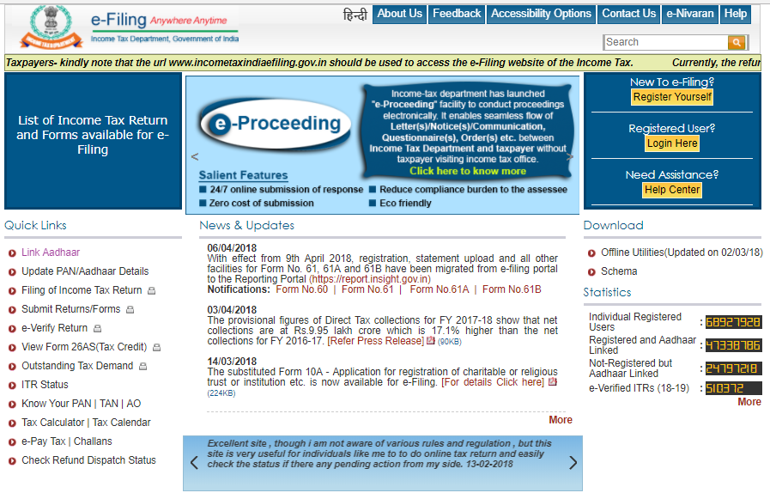  The figure above shows the front page of the Indian Government Income Tax Department website. You have been assigned the task of designing a mobile-friendly version of this page that can be viewed effectively on small screens, such as mobile phones or PDAs. The redesigned page must retain the same functionality and content as the current version.  a. Outline a structured plan to identify the specific needs of mobile users accessing the website. Your plan should focus on layout-related aspects to ensure usability and accessibility on small screens while preserving the website's core functionalities. [15]  b. Describe the systematic procedures you would implement to evaluate the effectiveness of your redesigned mobile-friendly version. [15]  c. Design a mobile-compatible user interface by providing at least two screen diagrams that illustrate your proposed layout and navigation structure. [15]  d. Justify the utilization of the Eight Golden Rules of Interface Design in your proposed interface. Additionally, discuss the advantages of applying these principles to enhance usability and user experience in your design. [15]  e. Illustrate the implications of the GOMS (Goals, Operators, Methods, and Selection Rules) model in analysing your UI design. Explain how the model helps in evaluating user interactions and improving task efficiency. [15] |  |  |  |  | 75
2 |  | You have been hired as a UX designer for a leading corporate firm tasked with designing a technology-supported small workroom that facilitates face-to-face collaboration for small to medium-sized groups (2-6 people). The goal is to create an environment that enhances team interaction, productivity, and seamless information sharing.  a. Assume that the firm aims to equip the workroom with advanced display technologies to support effective collaboration. Identify and briefly explain five key factors you need to consider when selecting and outfitting the room with display solutions, keeping in mind the usability, accessibility, and technological integration requirements. [10]  b. Design mock UI layouts for the workroom's display interfaces, providing at least three screen designs that showcase how users will interact with the display systems for activities such as presentations, brainstorming sessions, and remote collaboration. Ensure your designs address user experience principles and collaboration efficiency. [15] |  |  |  |  | 25

